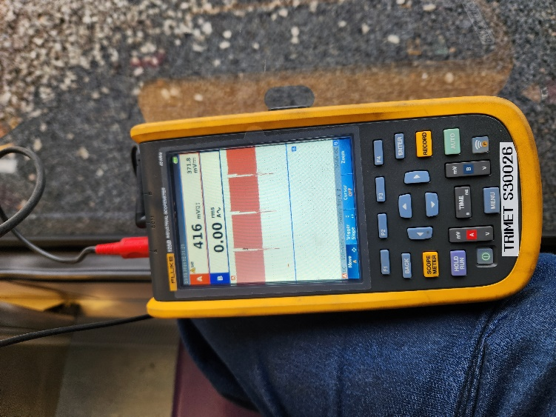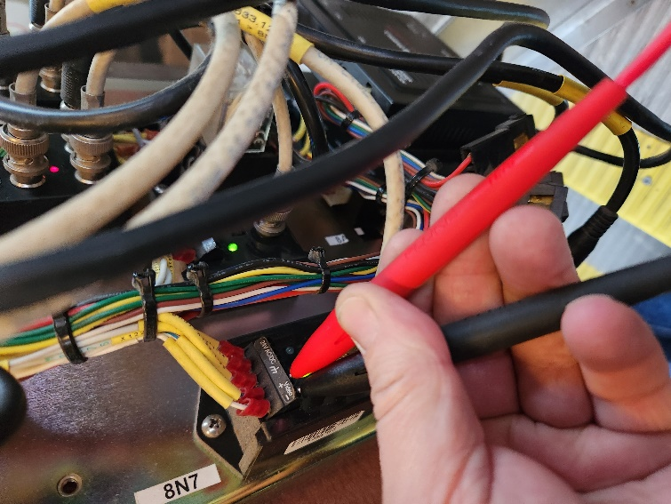Sampling wave image waveform with an oscilloscope

Figure : sample of a pretty good wave form

I have been using an oscilloscope to sample waveforms and determine if a signal is making it to an area I am sampling at. This is useful for stuff

